Para obtener información sobre como este cambio afectará su factura y/o una copia de esta notificación en español visite www.sce.com/avisos

NOTICE OF APPLICATION OF
SOUTHERN CALIFORNIA EDISON COMPANY
TO INCREASE ELECTRIC RATES
APPLICATION A.23-01-020

Why am I receiving this notice?
On January 31, 2023, Southern California Edison Company (SCE) filed an application with the California Public Utilities Commission (CPUC) requesting an expedited review and approval of its 2023 Energy Resource Recovery Account (ERRA) Revenue Requirement Trigger Mechanism Application (Application). The ERRA functions to recover the fuel and power procurement costs that SCE incurs to provide electric service to its customers.

As of April 30, 2023, SCE is forecasting to spend $595.615 million more in actual procurement costs than has been recovered in customer rates. This is known as the “Undercollection Amount.” This is due to a variety of factors which include, among others, very high natural gas prices. If SCE’s Application is approved, your rates may increase as reflected in the table below.

Why is SCE requesting this rate increase?
The CPUC requires SCE to promptly file an application for recovery of the Undercollection Amount. Pursuant to this requirement, SCE filed the Application and requests that the CPUC allow SCE to include the Undercollection Amount in rates beginning June 1, 2023.

How could this affect my monthly electric rates?
If the Undercollection Amount were to be put in rates today, the average non-CARE residential monthly bill using 500 kWh per month would increase by approximately 3.9% (or $6.49) per month.

CUSTOMER BILL IMPACT TABLE
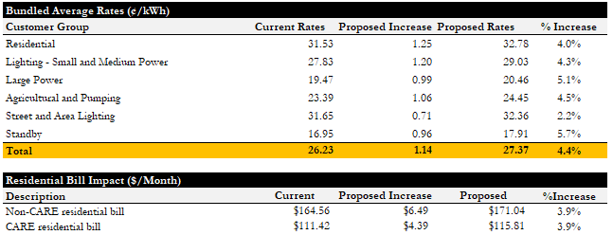

How does the rest of this process work?
This Application will be assigned to a CPUC Administrative Law Judge who will consider proposals and evidence presented during the formal hearing process. The Administrative Law Judge will issue a proposed decision that may adopt SCE’s Application, modify it, or deny it. Any CPUC Commissioner may sponsor an alternate decision with a different outcome. The proposed decision, and any alternate decisions, will be discussed and voted upon by the CPUC Commissioners at a public CPUC Voting Meeting.

Parties to the proceeding may review SCE's Application, including the Public Advocates Office. The Public Advocates Office is an independent consumer advocate within the CPUC that represents customers to obtain the lowest possible rate for service consistent with reliable and safe service levels. For more information about the Public Advocates Office, please call 1-415-703-1584, email PublicAdvocatesOffice@cpuc.ca.gov, or visit PublicAdvocates.cpuc.ca.gov.

Where can I get more information?

Contact SCE:
Phone: 1-800-655-4555
Email: case.admin@sce.com
Mail:
Eric Lee
Southern California Edison Company
A.23-01-020 – SCE’s 2023 ERRA Trigger Application
P.O. Box 800 Rosemead, CA 91770

A copy of the Application and any related documents may also be reviewed at www.sce.com/applications by searching for the Application name or A.23-01-020.

Contact CPUC:
Please visit apps.cpuc.ca.gov/c/A2301020 to submit a comment about this proceeding on the CPUC Docket Card. Here you can also view documents and other public comments related to this proceeding.

Your participation by providing your thoughts on SCE’s request can help the CPUC make an informed decision.

If you have questions about CPUC processes, you may contact the CPUC’s Public Advisor’s Office at:
Phone: 1-866-849-8390 (toll-free) or 1-415-703-2074
Email: Public.Advisor@cpuc.ca.gov
Mail: CPUC Public Advisor’s Office
505 Van Ness Avenue
San Francisco, CA 94102

Please reference SCE’s ERRA Trigger Application 23-01-020 in any communications you have with the CPUC regarding this matter.

